Functional Requirements

* create account.
* view tasks
* edit task
* Add task
* delete task
* Comply with legal rules/expectations
* Task completion is to be done by the user only
* Reward awarded if a task is completed.
* If user completes all tasks for the day then award full reward

Non-functional Requirements

Usability

* activating snooze for notifications for X minutes
* set due date and time for each task
* Change font size/colour
* connection to peripherals such as Bluetooth devices
* The app meets the needs of users with wide range of needs (that is the app ought to be highly customisable)

Reliability

* check username and password meet the constraints in place for security
* change password and/or username
* Use low CPU resources (figure 1)
* There should be a backup system for data recovery

Performance

* short response time (such as in user input and expected out put)
* Short response time when navigating between screens

Security

* User data must be stored securely by secure login or encryption
* unauthorised access must be stopped

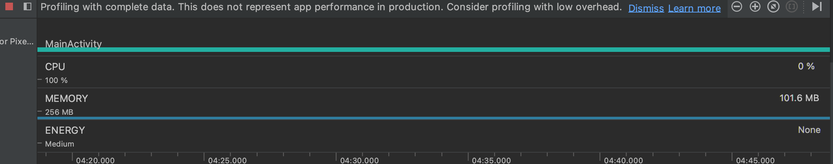

Figure 1. Analyzing app performance by using Android Profiler

| Use case vs domain class | Priority | SortType | ToDo | ToDoDatabase | ToDoViewModel | ToDoState | User | Account | User InfoDB |
| --- | --- | --- | --- | --- | --- | --- | --- | --- | --- |
| Create User Account |  |  |  | U |  |  | C | C | U |
| Delete User Account |  |  | R | R |  | R | D | D | U |
| Check User Names and Password |  |  |  |  |  |  | R | R | R |
| Change Username/  Password |  |  |  |  |  |  | R/U | R/U | U |
| Add task name | U |  | C | U |  | C |  |  |  |
| Set Priority | C | C | U | U |  |  |  |  |  |
| Start Task |  |  |  |  | U |  |  |  |  |
| Assign task as completed | D |  | D | R/D | D | D |  |  | U |
| Add Due Date | U | C |  | U |  | C |  |  |  |
| Set Reminder |  |  |  | R | U | R |  |  |  |
| Add due time | U |  |  | U |  | C |  |  |  |
| Activate timer |  |  |  |  | U |  |  |  |  |
| Pause timer |  |  |  |  |  |  |  |  |  |
| Resume timer |  |  |  |  |  |  |  |  |  |
| Activate snooze |  |  |  |  |  |  |  |  |  |
| Display push notifications |  |  |  | R | U |  |  |  |  |
| View push notifications |  |  |  |  |  |  |  |  |  |
| View Tasks Due today |  |  |  | R | U |  |  |  |  |
| Create tasks due today |  |  |  | R |  |  |  |  |  |
| Update database | R | R | R | U | R | R |  |  |  |
| Edit task | R/U | R/U | R/U | U | U | U |  |  |  |
| Delete task | U | U | U | U | R | U |  |  |  |

*CRUD* Table showing use cases and domain class